**IMAGE BLENDING**

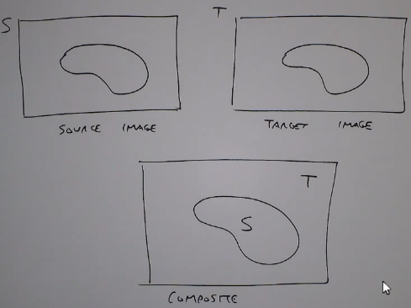

Used in image mosaicking.

The art lies not just in taking the portion of source S and pasting it on T. It lies in disguising the intensities across the portion of source image to make visually perceptible. It is smoothened around the edges of the seam.

***Hard compositing***:

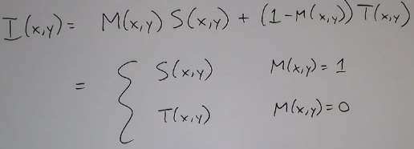

Where M is mask, S is source and T is target.

But here the seam/matte line is visible.

***Weighted Transition Region***:

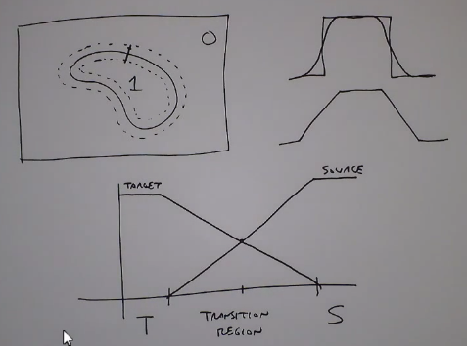

Draw a band around the mask for a certain width. There is a choice of making increasing the width of the profile to make it look more diffused.

This is not so satisfying answer.

***Multi-resolution blending with Laplacian Pyramid***

The idea is to have:

* Wide transition regions for low frequency components
* Low transition regions for high frequency components

The Gaussian Pyramid:

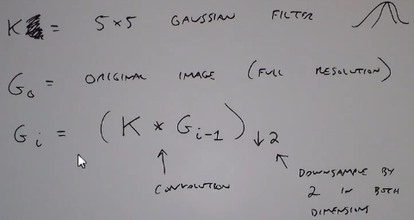

Now we need to find the edges at each of these scales. Also called the difference of the Gaussians at each scale.

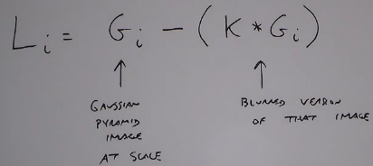

This is like a high-pass image at scale ‘I’.

. It is a set of edge images at different scales.

As a result, in higher scales at smaller images, the insignificant edges are blurred away. Hence at the last scaled image (smallest) only those edges that are really strong in the original image stand out. Hence, Laplacian pyramid has this collection of edge information at various scales.it Is detailed decomposition of edges.

We can recover the original image from small downsampled image by:

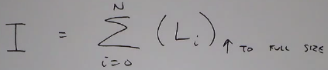

The idea is add back all the edges at different scales and the base image is the smallest and blurriest image.

To do image composition, compute the Laplacian pyramids for the source (S), target (T) . Then compute the Gaussian pyramid for mask M.

Laplacian pyramid for composite is computed as:

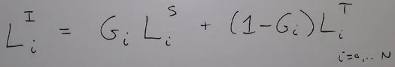

Then add up to get the final composite.